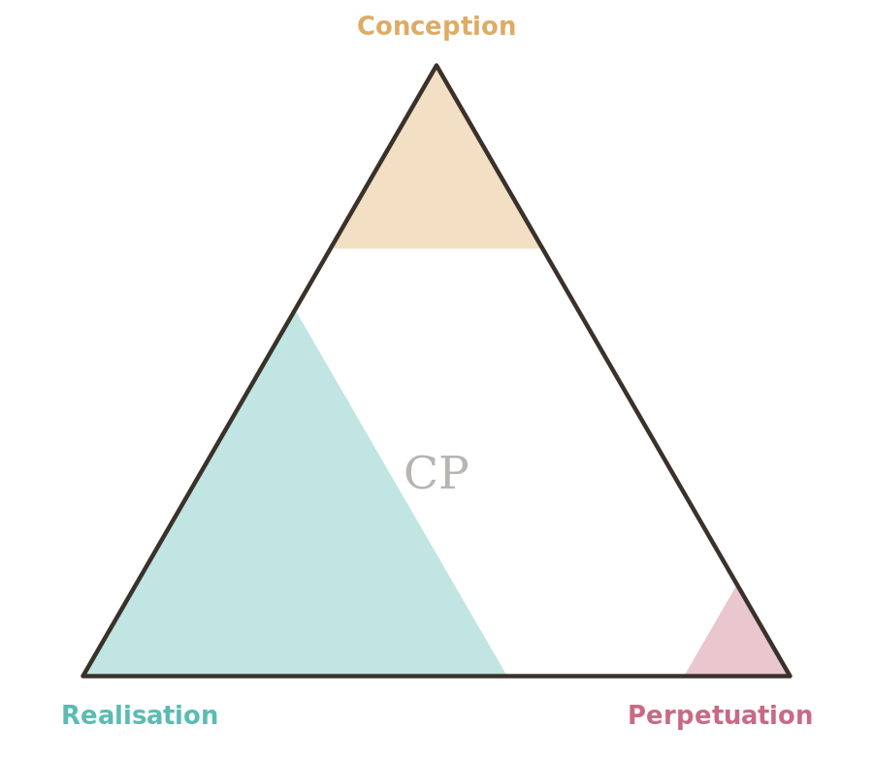

CProvenance — Launch & Adoption Kit
Taking the standard public

1. Positioning
CProvenance is the missing middle layer of AI disclosure: more informative than a binary “made with AI” label, more universal than domain-specific schemes, and more human-readable than cryptographic provenance. The one-line pitch: one mark and three numbers that say how much of any work came from AI — and at which stage of its life.
Position it as infrastructure, not judgement. Like Creative Commons, it is a shared vocabulary any creator can adopt in minutes and any platform can index; it describes a process without ranking it. The framework must never read as either pro- or anti-AI — its credibility rests on being equally useful to the proudly hand-made and the proudly machine-made.
The triangle is the brand, the CP(C/R/P) notation is the standard, and the framework document is the authority behind both. Everything public should lead with the working toolkit: a standard people can try in ten seconds beats one they can only read about.

2. Audiences and messages
Audience | What they need to hear
Creators & studios | “Disclose your process honestly without being penalised. One mark works across everything you make.”
Platforms & publishers | “One consistent disclosure field across every content type you host — with structured metadata you can index.”
Institutions & regulators | “A standardised, auditable vocabulary for AI involvement that maps onto the EU AI Act and ISO/IEC 42001.”
Consumers & citers | “See at a glance how a work was made, and cite it accurately.”

3. Key messages
- Not binary. AI involvement is a spectrum; disclosure should be too.
- Universal. One framework for every domain, grounded in how anything is created: Think, Make, Tend.
- Honest, not judgemental. It describes; it does not rank.
- Glance plus detail. A triangle for the eye, CP(C/R/P) for the record, metadata for the machine.
- Complementary. Sits alongside C2PA, Creative Commons, and regulation rather than competing with them.

4. Channels
Lead with the working toolkit — a standard you can try in ten seconds is far more persuasive than a PDF. Suggested order: a landing site hosting the rating tool, badge generator and decoder; the framework and quick-start as downloads; a launch write-up explaining the gap and the three-part model; targeted outreach to standards bodies (C2PA, IPTC), creator communities, and a handful of friendly publishers willing to mark their own content; and a short demo video showing one work scored end-to-end.

5. Launch checklist

Phase 1 — Foundations (now)
- Finalise v0.2 of the framework and the quick-start guide.
- Publish the toolkit (rating tool, badge generator, score decoder).
- Lock the brand: mark, colours, wordmark, and downloadable assets.
- Register a home for the spec and a stable namespace URL for metadata.

Phase 2 — Soft launch (weeks 1–4)
- Score this kit’s own documents and display their marks (lead by example).
- Recruit 5–10 pilot creators across different domains to score real works.
- Gather feedback against the open questions in §12 of the spec.
- Publish 2–3 worked case studies with visible marks.

Phase 3 — Public launch (weeks 5–8)
- Publish the launch write-up and demo video.
- Open a public channel for contributions and disputes.
- Approach one standards body and one platform for a pilot integration.
- Offer copy-paste embed snippets for common CMS and publishing tools.

Phase 4 — Iterate toward v1.0 (months 3–6)
- Consolidate feedback; decide on the Source (S) dimension and verification.
- Define an audit / challenge process for contested scores.
- Pursue formal registration of the mark and namespace.
- Ship integration guides for the most-requested platforms.

6. Success signals
Early adoption is qualitative before it is quantitative. Watch for: works in the wild carrying the mark; a standards body or platform agreeing to a pilot; unsolicited domain-specific scoring guides from communities; and press or academic references that use the CP(C/R/P) notation as shorthand. Vanity metrics (page views) matter less than whether real creators mark real works.

7. Frequently asked questions
Is a high score bad?
No. The framework describes; it does not judge. CP(95/98/90) and CP(0/0/0) are equally valid disclosures — the point is that the reader knows which one they are looking at.
Do spell-checkers and similar tools mean I must disclose AI involvement?
No. Passive tools — spell-checkers, calculators, autofocus — do not count. Involvement means AI made or substantively shaped decisions, generated content, or performed creative or analytical work.
How is this different from C2PA?
C2PA cryptographically records what happened to a file; CProvenance summarises, in human terms, how much of the work AI did across its whole life. They are complementary — a CProvenance score can travel inside a C2PA manifest as an assertion.
Can’t people just lie?
Yes — v0.2 is self-assessment, like choosing a Creative Commons licence. The immediate goal is a norm of disclosure and a shared vocabulary; verification, audit and challenge mechanisms are on the roadmap toward v1.0.
AI models are trained on human work — doesn’t that make every score misleading?
The score measures the creator’s process, not the tool’s ancestry. What a work is made of is content provenance, addressed today by the optional material_inputs field and in future by the proposed Source dimension, CP(C/R/P/S).
Provenance: CP(35/75/5) · scored 7 July 2026 under CProvenance v0.2 — human-directed concept, structure and editing; AI-assisted research and drafting; human-led stewardship with AI assistance.

