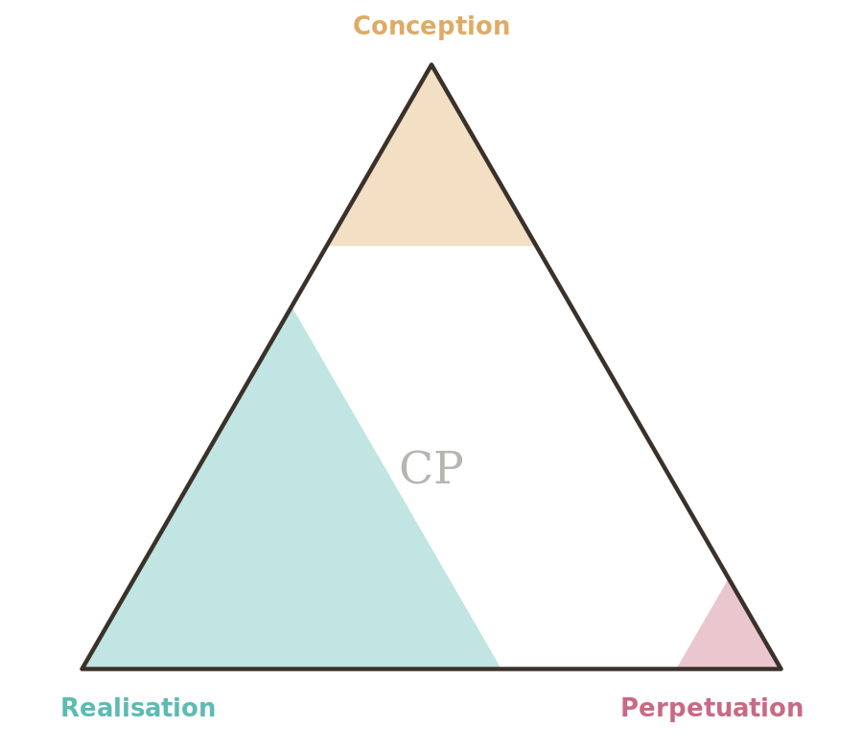

CProvenance
Universal Creative Provenance Framework

A standard for transparent disclosure of AI involvement in the creation and stewardship of any work

Version 0.2 · Draft for Discussion · June 2026

Contents

1. Executive Summary
CProvenance is a universal framework and visual mark for disclosing the nature and extent of artificial-intelligence involvement in the creation and stewardship of any work. It applies equally to a painting, a software product, a news article, a scientific paper, a cake recipe, or a political manifesto.
The framework is built on a domain-agnostic model of how things come into existence — the Universal Creation Lifecycle — which divides the life of any created thing into three fundamental parts: Conception (thinking), Realisation (making), and Perpetuation (tending). By scoring AI involvement independently across these three dimensions, CProvenance captures the nuance that most existing disclosure schemes miss: a work can be AI-conceived but human-made, or human-conceived but AI-produced, or any combination thereof.

2. Purpose and Rationale

2.1 The Problem
As AI capabilities advance, the binary question “was this made by AI?” is becoming both ubiquitous and inadequate. Most works now exist on a spectrum of human–AI collaboration, and a simple yes/no label fails to capture meaningful differences. A photograph retouched by AI is different from one generated entirely by AI. A research paper where AI assisted with literature review is different from one where AI wrote the conclusions. A product designed by humans but manufactured by AI-controlled processes is different from one conceived, designed, and produced entirely by AI.
Current disclosure approaches typically suffer from one or more of three problems. They are binary, offering no granularity. They are domain-specific, designed for images or text but inapplicable to other forms of work. Or they focus only on the moment of creation, ignoring AI involvement in the conception, planning, maintenance, and evolution of a work.

2.2 The Solution
CProvenance addresses all three problems by providing a framework that is granular (percentage-based across three independent dimensions), universal (grounded in a lifecycle model that applies to any domain), and comprehensive (covering the full life of a work from inception to retirement).
The framework serves four key audiences:
- Creators and producers who wish to be transparent about their use of AI, for ethical reasons and to accurately represent their work.
- Consumers and audiences who want to make informed decisions about the works they engage with, purchase, or cite.
- Institutions and regulators who need a standardised way to assess, audit, and set policy around AI-assisted creation.
- Platforms and publishers who require a consistent disclosure mechanism across diverse content types.

2.3 Design Principles
- Universality. The framework must apply to any created thing in any domain, without modification to its core structure.
- Granularity. Disclosure must capture degrees of AI involvement, not merely its presence or absence.
- Dimensionality. AI involvement in different phases must be scored independently, because they carry different implications.
- Simplicity. The mark must be immediately comprehensible at a glance, with detail available on inspection.
- Honesty. The framework describes, it does not judge. Higher AI involvement is not presented as better or worse than lower.
- Interoperability. The framework must be expressible as metadata, embeddable in any medium, and compatible with existing standards.

3. The Universal Creation Lifecycle
CProvenance rests on a lifecycle model that describes how any created thing comes into being and persists. The model identifies eleven phases grouped into three parts. Every created thing passes through some or all of these phases, though the time spent in each varies enormously — from seconds (a sketch) to centuries (a legal system).

Phase | Part | Guiding question | What it covers
Inception | Conception | What if…? | The originating impulse — a need identified, a question posed, a vision conceived.
Investigation | Conception | What’s out there? | Understanding the landscape — what exists, what constrains, what precedes.
Assessment | Conception | Should we? | Determining viability — can it be done, should it, and at what cost?
Design | Conception | How exactly? | Planning the structure — blueprinting, outlining, architecting the approach.
Resourcing | Realisation | What do we need? | Acquiring what’s needed — materials, funding, people, tools, permissions.
Creation | Realisation | Can we build it? | The actual making — building, writing, coding, painting, proving, baking.
Validation | Realisation | Is it good enough? | Confirming it works — testing, reviewing, critiquing, debugging, tasting.
Release | Realisation | Is it ready? | Putting it into the world — launching, publishing, exhibiting, serving.
Stewardship | Perpetuation | How is it doing? | Ongoing care — monitoring performance, maintaining function, supporting users.
Evolution | Perpetuation | What’s next? | Deliberate adaptation — new versions, reinterpretations, extensions, reforms.
Retirement | Perpetuation | When does it end? | End of active life — deprecation, archiving, and the legacy left behind.

3.1 The three parts
Conception (Think) is everything that happens before making begins: the originating impulse, investigation of what already exists, assessment of whether to proceed, and the design of how. It is where a work’s identity is settled — what it is, why it should exist, and what form it will take. AI involvement here shapes the work most fundamentally, even when no AI touches the final artefact.
Realisation (Make) turns intent into artefact: gathering what is needed, the act of creation itself, validation that the result works, and release into the world. It is the most visible part of the lifecycle, and the only one that most existing disclosure schemes address.
Perpetuation (Tend) is everything after release: stewardship of the work in use, its deliberate evolution, and eventually its retirement. For a sketch this part may last moments; for a legal system, centuries. AI involvement in this part often grows over a work’s life, which is one reason scores are dated and may be revised (§4.2).

3.2 Structural Properties
The model is descriptive, not prescriptive. Phases are listed in the order they typically begin, but real work loops and overlaps: validation feeds back into creation, and evolution re-enters conception in miniature. Iteration does not invalidate a score; each dimension summarises the whole of its part, however tangled the path through it.
Not every work passes through every phase. An unpublished poem never reaches Release; a one-off meal has no Evolution. Phases that did not occur are simply absent from consideration — they neither raise nor lower a score. Where a part has not yet begun, most commonly Perpetuation at the moment of release, it is scored 0 and the recorded date signals that the value is provisional.
The three parts are independent by construction. High AI involvement in one implies nothing about the others, and no weighting between parts is defined: CP(90/10/0) and CP(10/90/0) describe very different works, and the notation deliberately resists reducing them to the same number.

4. The CProvenance Score

4.1 Structure
A CProvenance score is three integers, each between 0 and 100, giving the estimated percentage of AI involvement in — in fixed order — Conception, Realisation and Perpetuation. It is written CP(C/R/P): for example, CP(15/60/5) declares light AI involvement in the conception, substantial involvement in the making, and minimal involvement in stewardship to date. Values are rounded to the nearest 5 percentage points (§4.2), and a score is always accompanied by the date on which it was assigned and, where published, the framework version used.
A single aggregate percentage may be derived as the unweighted mean of the three values, but the three-dimensional score is always primary — the aggregate obscures meaningful variation.

4.2 Scoring Methodology
Each dimension answers: what proportion of the meaningful decisions, effort, and output in this part was performed by, or substantively directed by, AI rather than humans? Scoring follows four principles:
- Substance over tool use. Passive tools (a spell-checker, a calculator) do not count. Involvement means AI made or substantively shaped decisions, generated content, or performed creative or analytical work.
- Honest estimation. Scores are estimates, not measurements. Round to the nearest 5%. Favour honest approximation over false precision.
- Weighted significance. When AI involvement varied across sub-phases, weight by their importance, not a simple average.
- Point-in-time validity. Scores reflect involvement up to the point of scoring and may be updated as a work evolves. Always record the date.

4.3 Scoring Guide by Part
The following table gives indicative guidance for what each level of AI involvement looks like within each part.

Band | Conception (Think) | Realisation (Make) | Perpetuation (Tend)
None (0%) | Idea, research, judgement and design wholly human. | Built, tested and released entirely by human hands. | Stewardship, support and iteration entirely human — or not yet begun.
Light (1–25%) | AI used lightly — a brainstorming prompt or quick scan — but direction stays human. | AI used as a minor aid (a small draft, a quick check); the making is human. | Minor AI assistance in support or monitoring; humans steward the work.
Moderate (26–50%) | AI meaningfully contributed to research or options; humans made the key decisions. | AI produced a meaningful share of the output, substantially reworked by humans. | AI handles a meaningful part of monitoring, support or iteration alongside humans.
Substantial (51–75%) | AI generated much of the concept, framing or structure; humans curated and steered. | AI generated most of the output; humans reviewed, edited and assembled. | AI runs most ongoing stewardship and adaptation; humans oversee.
Predominant (76–100%) | Concept, framing, research and design originated predominantly from AI. | The artefact was produced predominantly by AI, with light human involvement. | The work is sustained and evolved predominantly by AI.

5. The CProvenance Mark

5.1 Symbol Design
The CProvenance mark is an equilateral triangle. Each vertex corresponds to one part of the lifecycle: the top vertex is Conception, the bottom-left is Realisation, and the bottom-right is Perpetuation.
AI involvement is represented by shading that extends inward from each vertex in proportion to the score for that dimension. At 0% there is no shading from that corner; at 100% the shading reaches the opposite edge. When multiple dimensions are high, their shaded regions overlap in the centre, naturally darkening to indicate pervasive AI involvement.
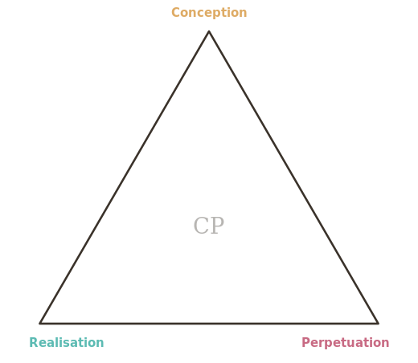
Empty outline = fully human (left). Shaded = AI involvement by part (right).

The mark has two canonical forms:
- Full colour. Each vertex’s shading uses its part colour — amber for Conception, teal for Realisation, rose for Perpetuation. Used where colour is reliable and space permits.
- Monochrome. All shading uses a single dark colour. Designed for small-scale reproduction, print, and watermarking. The CP monogram may be omitted at very small sizes.

5.2 Reading the Mark
- At a glance: the overall density of shading gives an immediate impression of how much AI was involved.
- On closer inspection: the distribution of shading across the three corners reveals which parts involved AI.
- With metadata: the exact CP(C/R/P) score, date, and notes are available in accompanying structured data.

5.3 Placement
Place the mark where provenance information is conventionally found for the type of work: the title page, colophon, or footer of documents; EXIF/XMP metadata and an optional visible watermark for images and video; the about page, README, or package metadata for software; packaging or labels for physical products; and the footer, JSON-LD, or meta tags for web content.

5.4 Minimum Reproduction Size
The full-colour mark with labels should be reproduced no smaller than 30 mm wide, and any labelled form no smaller than 15 mm. Between roughly 8 mm and 15 mm, use the bare shaded triangle without vertex labels (the watermark form), which still reads clearly at that scale. Below 8 mm, use the structured-metadata representation only.

6. Common Patterns
While scores are continuous, certain patterns recur often enough to warrant named archetypes. These are descriptive conveniences, not formal categories, and their typical scores are illustrative centroids rather than prescribed values — which is why they are not multiples of 5. A self-assessed score should still follow the rounding rule in §4.2.

Pattern | Typical score | Description
Fully Human | CP(0/0/0) | No AI involvement at any stage of the work’s life.
Human-Led | CP(≤15 each) | AI used only as a marginal aid; humans drive throughout.
AI-Assisted | CP(10/42/5) | AI helps with the making; humans conceive and tend the work.
Co-Created | CP(50/55/45) | A genuine human–AI collaboration distributed across the life.
Human-Refined AI | CP(82/90/15) | AI conceives and makes; a human curates, refines and tends.
Fully AI | CP(95/98/90) | AI is responsible for essentially the whole life of the work.

7. Domain Examples

7.1 Journalism
An investigative article. The lead, the interviews and the writing are human; AI analysed a large cache of leaked documents, surfaced patterns and suggested lines of enquiry; a human editor reviewed throughout. After publication, AI-assisted tools help monitor for corrections and follow-ups.
Scored CP(15/35/5): light AI involvement in conception (suggested angles), moderate in realisation (the document analysis materially shaped the published text), and minor AI assistance in stewardship.

7.2 Visual Art
A generative artwork. The artist began from directions proposed by a model, and the image itself was produced by AI across many prompted iterations, then curated, composited and hand-finished by the artist, who exhibits and maintains the work.
Scored CP(60/75/0): AI substantially shaped both the concept and the output; perpetuation remains entirely human.

7.3 Software Development
A production web application. The architecture and key design decisions are human; roughly 70% of the code was AI-generated and human-reviewed; testing was shared; monitoring and routine dependency updates are AI-assisted under human oversight.
Scored CP(15/65/30), re-scored at each major release — software is the clearest case of a work whose perpetuation score changes over its life.

7.4 Academic Research
An empirical paper. The research question, study design and data collection are human; AI ran the statistical analysis and drafted the methods and results sections, which the authors heavily rewrote; the conclusions are the authors’ own.
Scored CP(5/40/0). Had AI framed the hypothesis or written the conclusions, the Conception value would rise sharply — precisely the distinction a binary label cannot make.

7.5 Culinary Arts
A restaurant dish. AI proposed the concept and several unconventional flavour pairings; the chef developed, tested and refined the recipe, cooks the dish, and the kitchen keeps it on the menu.
Scored CP(55/5/0): a work substantially conceived by AI but almost entirely made by humans — the mirror image of the common assumption that AI only makes.

8. Derived Works and Material Inputs
The score describes how a work was made. This section addresses the adjacent question the score deliberately does not answer — what the work is made of — and how v0.2 lets creators disclose it.

8.1 The Problem
Consider a journalist who writes an article entirely by hand — CP(0/0/0) by the rules above — but whose article synthesises five AI-generated research briefs they commissioned. Is that really “fully human”? Conversely, a model may generate a report end-to-end — CP(95/95/0) — yet that report quotes and synthesises human-written sources retrieved by search. The output is AI-made, but its substance is largely human-originated.
CProvenance draws its boundary at the creator’s process and treats inputs as external. That is defensible, but incomplete. The distinction that matters is between process provenance (how was this made?) and content provenance (what is it made of?).

8.2 The v0.2 Approach: Material-Input Disclosure
Version 0.2 keeps the score focused on process and adds an optional material_inputs field to the structured data (§9), so a creator can flag — and briefly describe — that a work draws substantively on AI-derived inputs:

"cprovenance": {
"score": { "conception": 5, "realisation": 10, "perpetuation": 0 },
"material_inputs": {
"ai_derived": true,
"description": "Article synthesises five AI-generated research briefs"
}
}

8.3 Future Direction: a Source Dimension
Material-input disclosure is deliberately coarse: a flag and a free-text description. A future version may promote content provenance to a fourth scored dimension, Source (S), written CP(C/R/P/S), where S estimates the proportion of a work’s substance derived from AI-generated inputs.
The dimension is signalled now so that adopters can anticipate the notation, but it is kept out of the core until the three-dimensional model has been tested in practice. Source raises hard questions — recursive provenance (the sources’ own sources), the boundary between influence and incorporation, and feasibility for creators who cannot audit their inputs — which are held as open questions for v1.0 (§12.3). For high-stakes domains, a recursive extension that scores the material inputs themselves is under consideration.

9. Structured Data Specification
The score and its metadata should be machine-readable. The canonical representation is JSON, embedded in HTML as a script block. The published @context at https://cprovenance.org/ns.jsonld allows the same object to be expressed as full JSON-LD:
{
"@context": "https://cprovenance.org/ns.jsonld",
"cprovenance": {
"version": "0.2",
"score": { "conception": 15, "realisation": 60, "perpetuation": 5 },
"aggregate": 27,
"pattern": "AI-Assisted",
"scored_at": "2026-06-18",
"scored_by": "Author Name",
"work": "Title of Work",
"material_inputs": { "ai_derived": false },
"notes": "Optional free-text context"
}
}

For HTML, the data may also be expressed as meta tags:
<meta name="cprovenance:conception" content="15">
<meta name="cprovenance:realisation" content="60">
<meta name="cprovenance:perpetuation" content="5">
<meta name="cprovenance:version" content="0.2">

10. Implementation Guidance

10.1 Self-Assessment
In its initial form, CProvenance is a self-assessment framework: the creator or responsible party scores their own work, much as a rights-holder selects a Creative Commons licence. Self-assessment has limits, but it establishes a norm of disclosure and a shared vocabulary for discussing AI involvement.

10.2 Scoring Process
For each part, the scorer should:
- List the activities that occurred within that part.
- For each, estimate the proportion of meaningful work done by AI versus humans.
- Weight the activities by their significance to the part.
- Arrive at a single percentage, rounded to the nearest 5%.
For straightforward cases this should take only a few minutes.

10.3 When to Score
Assign a score at the point of release; update it when the work undergoes significant evolution; and re-score periodically for long-lived works whose perpetuation changes in character.

10.4 Disputes and Verification
The framework does not yet provide a verification or audit mechanism. Future versions may define criteria for third-party audit, automated detection, or community challenge.

11. Relationship to Existing Standards
CProvenance complements, rather than replaces, existing standards:
- C2PA. Scores can be embedded in C2PA manifests as an assertion, adding semantic meaning to C2PA’s technical provenance.
- Creative Commons. CC licences address rights and permissions; CProvenance addresses process and attribution. They are orthogonal.
- EU AI Act. CProvenance provides a structured mechanism for meeting AI-generated-content disclosure obligations.
- IPTC and XMP. Existing image and document metadata standards can carry CProvenance data in their extensible fields.
- ISO/IEC 42001. CProvenance aligns with this AI-management standard’s principles of transparency and accountability.

12. Governance and Versioning
This is version 0.2 of the CProvenance Framework, released as a draft for discussion and refinement.

12.1 Versioning
- Major versions (1.0, 2.0) indicate structural changes to the lifecycle model, scoring methodology, or mark.
- Minor versions (0.1, 0.2) indicate additions, clarifications, or expanded guidance.
- Scores should record the version used (e.g. “scored under CProvenance v0.2”).

12.2 Changes in v0.2
- Added Section 8, Derived Works and Material Inputs, distinguishing process from content provenance and introducing the optional material_inputs field.
- Signalled a future Source (S) dimension, CP(C/R/P/S), and a recursive extension for high-stakes domains.
- Added a public toolkit: an interactive rating tool, badge generator, and score decoder.

12.3 Open Questions for Future Versions
- Verification and audit mechanisms for scores.
- Weighting of sub-phases within each part for more precise scoring.
- Guidance for complex works with multiple contributors who used AI differently.
- Formal registration of the mark and namespace.
- Integration specifications for major platforms and publishing systems.
- Accessibility guidance for the mark (alt text, screen-reader descriptions).
- The Source dimension and the treatment of derived works.

12.4 Contributing
This framework is an open draft. Feedback, critique, domain-specific testing, and contributions are welcomed, with the goal of developing CProvenance through broad consultation into a standard that is genuinely useful, widely adopted, and robustly designed.

△
CProvenance Framework v0.2 · June 2026 · Draft for Discussion
Provenance: CP(35/75/5) · scored 7 July 2026 under CProvenance v0.2 — human-directed concept, structure and editing; AI-assisted research and drafting; human-led stewardship with AI assistance.

